Website Article for Business Leadership of the Future
Business Leadership of the Future Programme: Successful Global Virtual Learning Experience
We are excited to announce the successful completion of the Business Leadership of the Future Programme, a 2-day online business learning programme held on 21 – 22 December 2024. This programme brought together over 100 high school students from more than 26 countries around the globe, including Indonesia, Germany, South Africa, and many more. The initiative aims to inspire the next generation of business leaders by providing them with valuable and practical experiences during these 2 days.
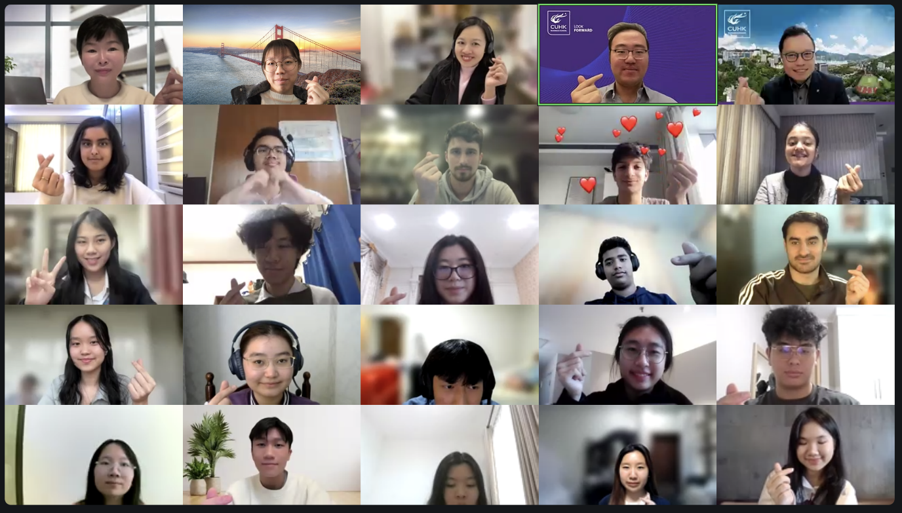
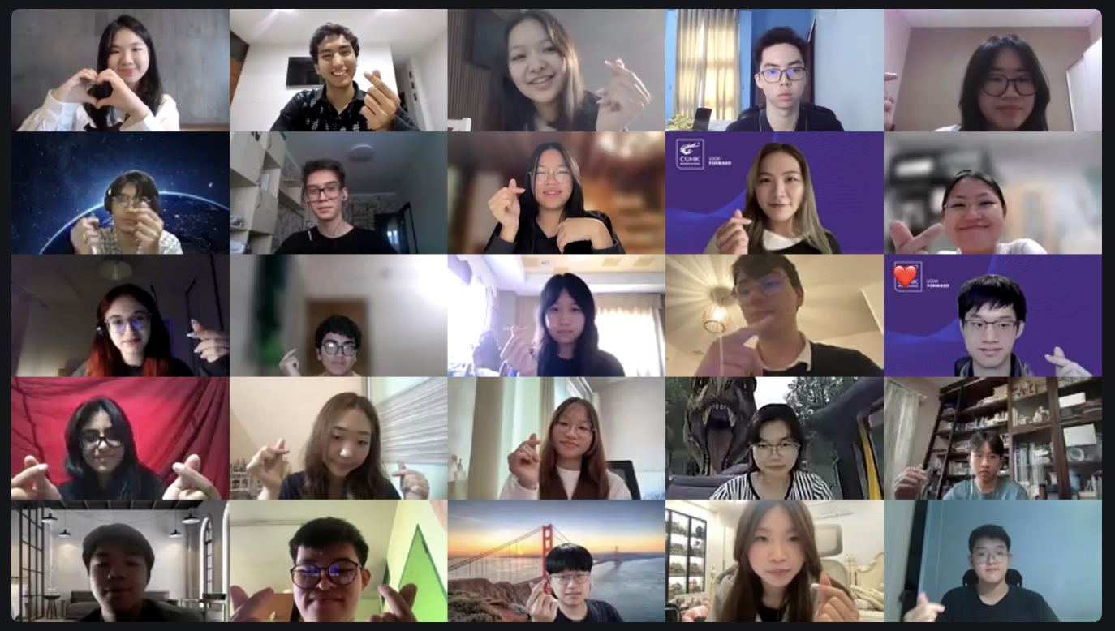Judges, Speakers and Participants’ Group photo with heart
Engaging Lectures from Leading Academics
Participants were fortunate to receive the lectures from esteemed faculty members, including Dr. Fred KU, the Associate Dean (Undergraduate Studies) of CUHK Business School, and Dr. Rosette LEUNG, Associate Director of the IBBA Programme, CUHK Business School. Their expertise and engaging teaching methods provided students with a deep understanding of contemporary business challenges and leadership strategies.
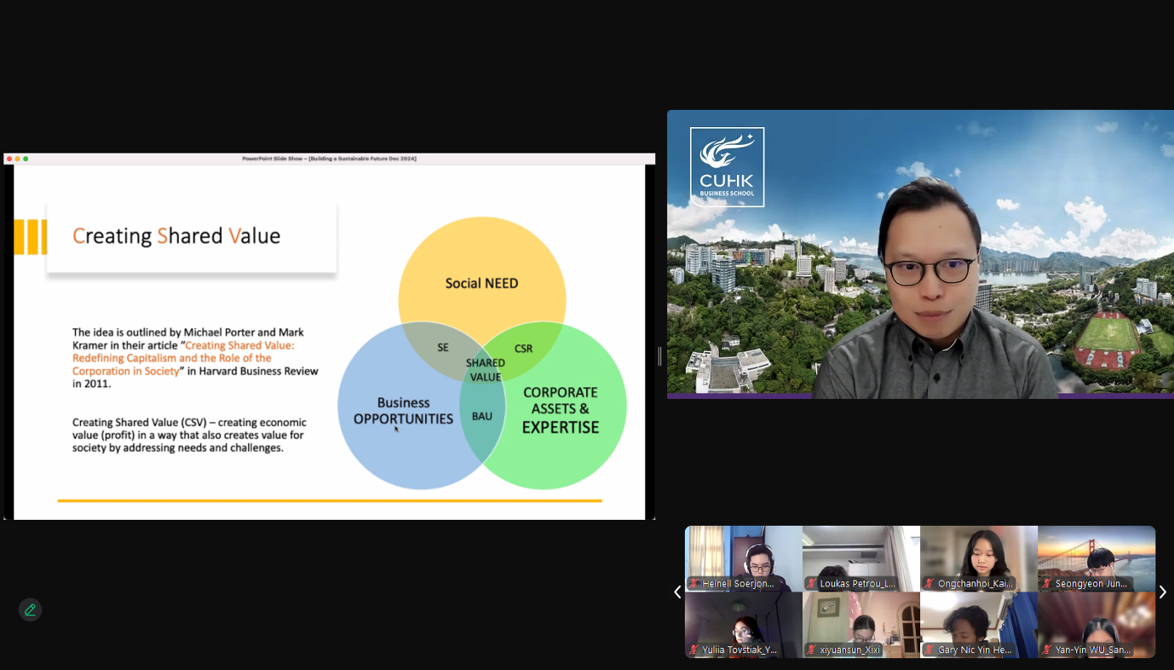Dr. Fred KU, the Associate Dean (Undergraduate Studies) of CUHK Business School delivered the lecture on sustainable and responsible business development to participants
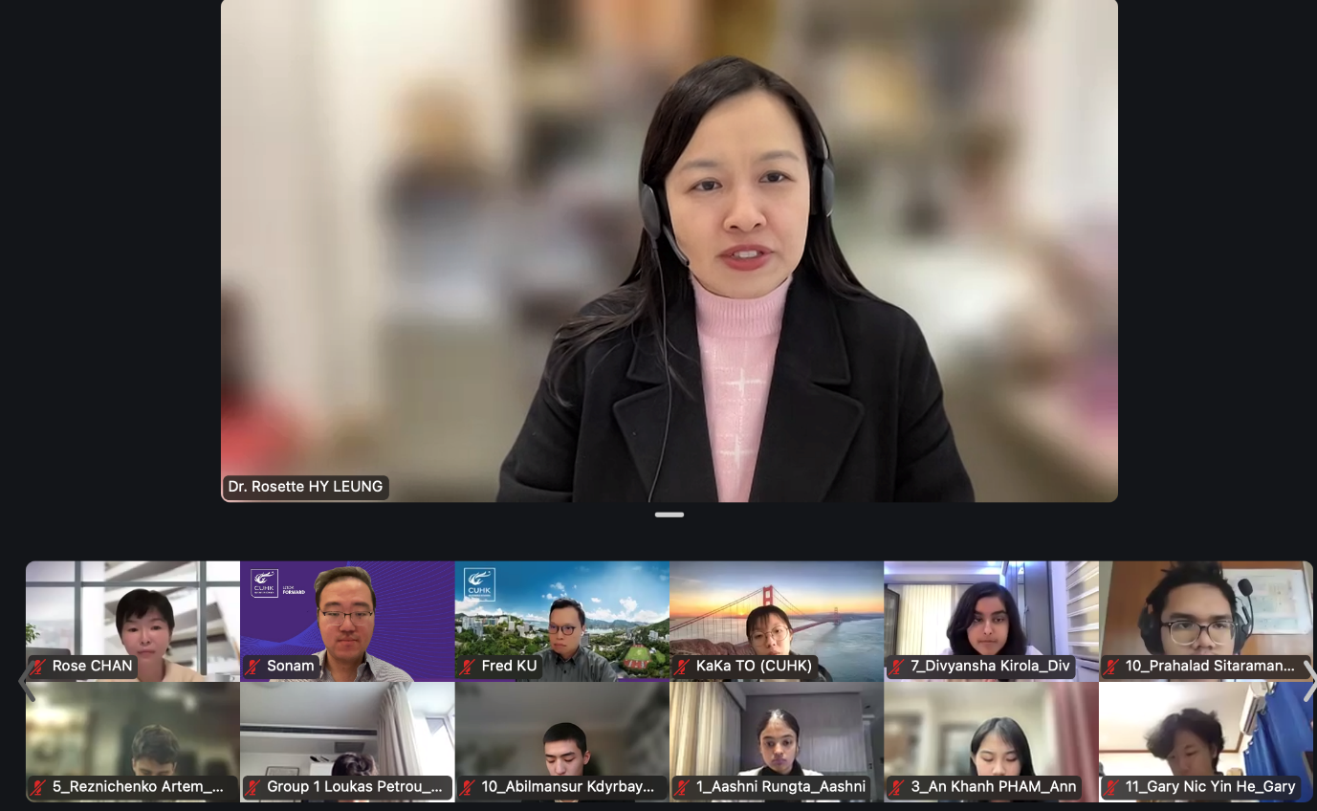Participants were fully engaged in the lecture delivered by Dr. Rosette LEUNG, Associate Director of IBBA Programme, CUHK Business School
Sharing from CUHK Business School Students
To further enrich the learning experience, Leanna HO (GLEF, Year 3), a student from Macau, shared her experiences on student leadership and college life at CUHK. Her firsthand accounts provided valuable information in helping participants gain a realistic understanding of what to expect in their future studies.
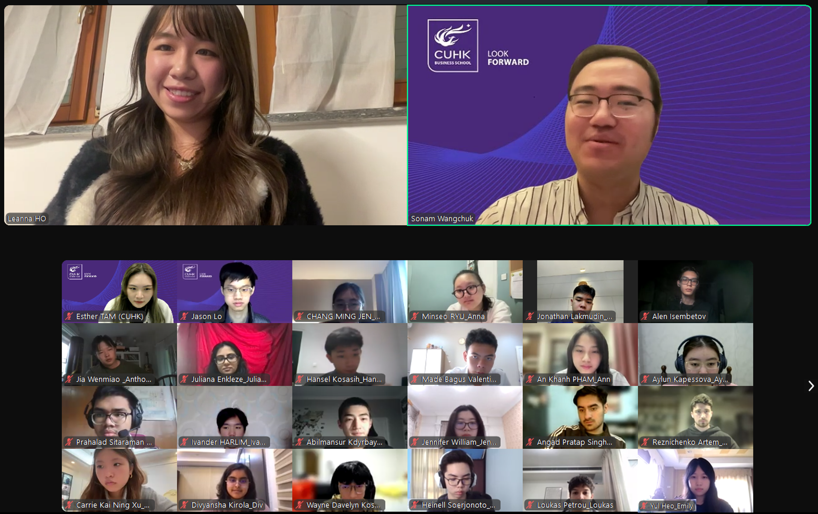Leanna HO (GLEF, Year 3) shared her student leadership opportunity in CUHK
Additionally, Kylie Feodorea CHAN (IBBA, Year 2), a student from Indonesia, shared her previous experience as a participant in the Business Leadership of the Future programme in 2022. Kylie’s insights highlighted the skills and knowledge she acquired from this programme, which emphasized the importance of leadership development and networking.
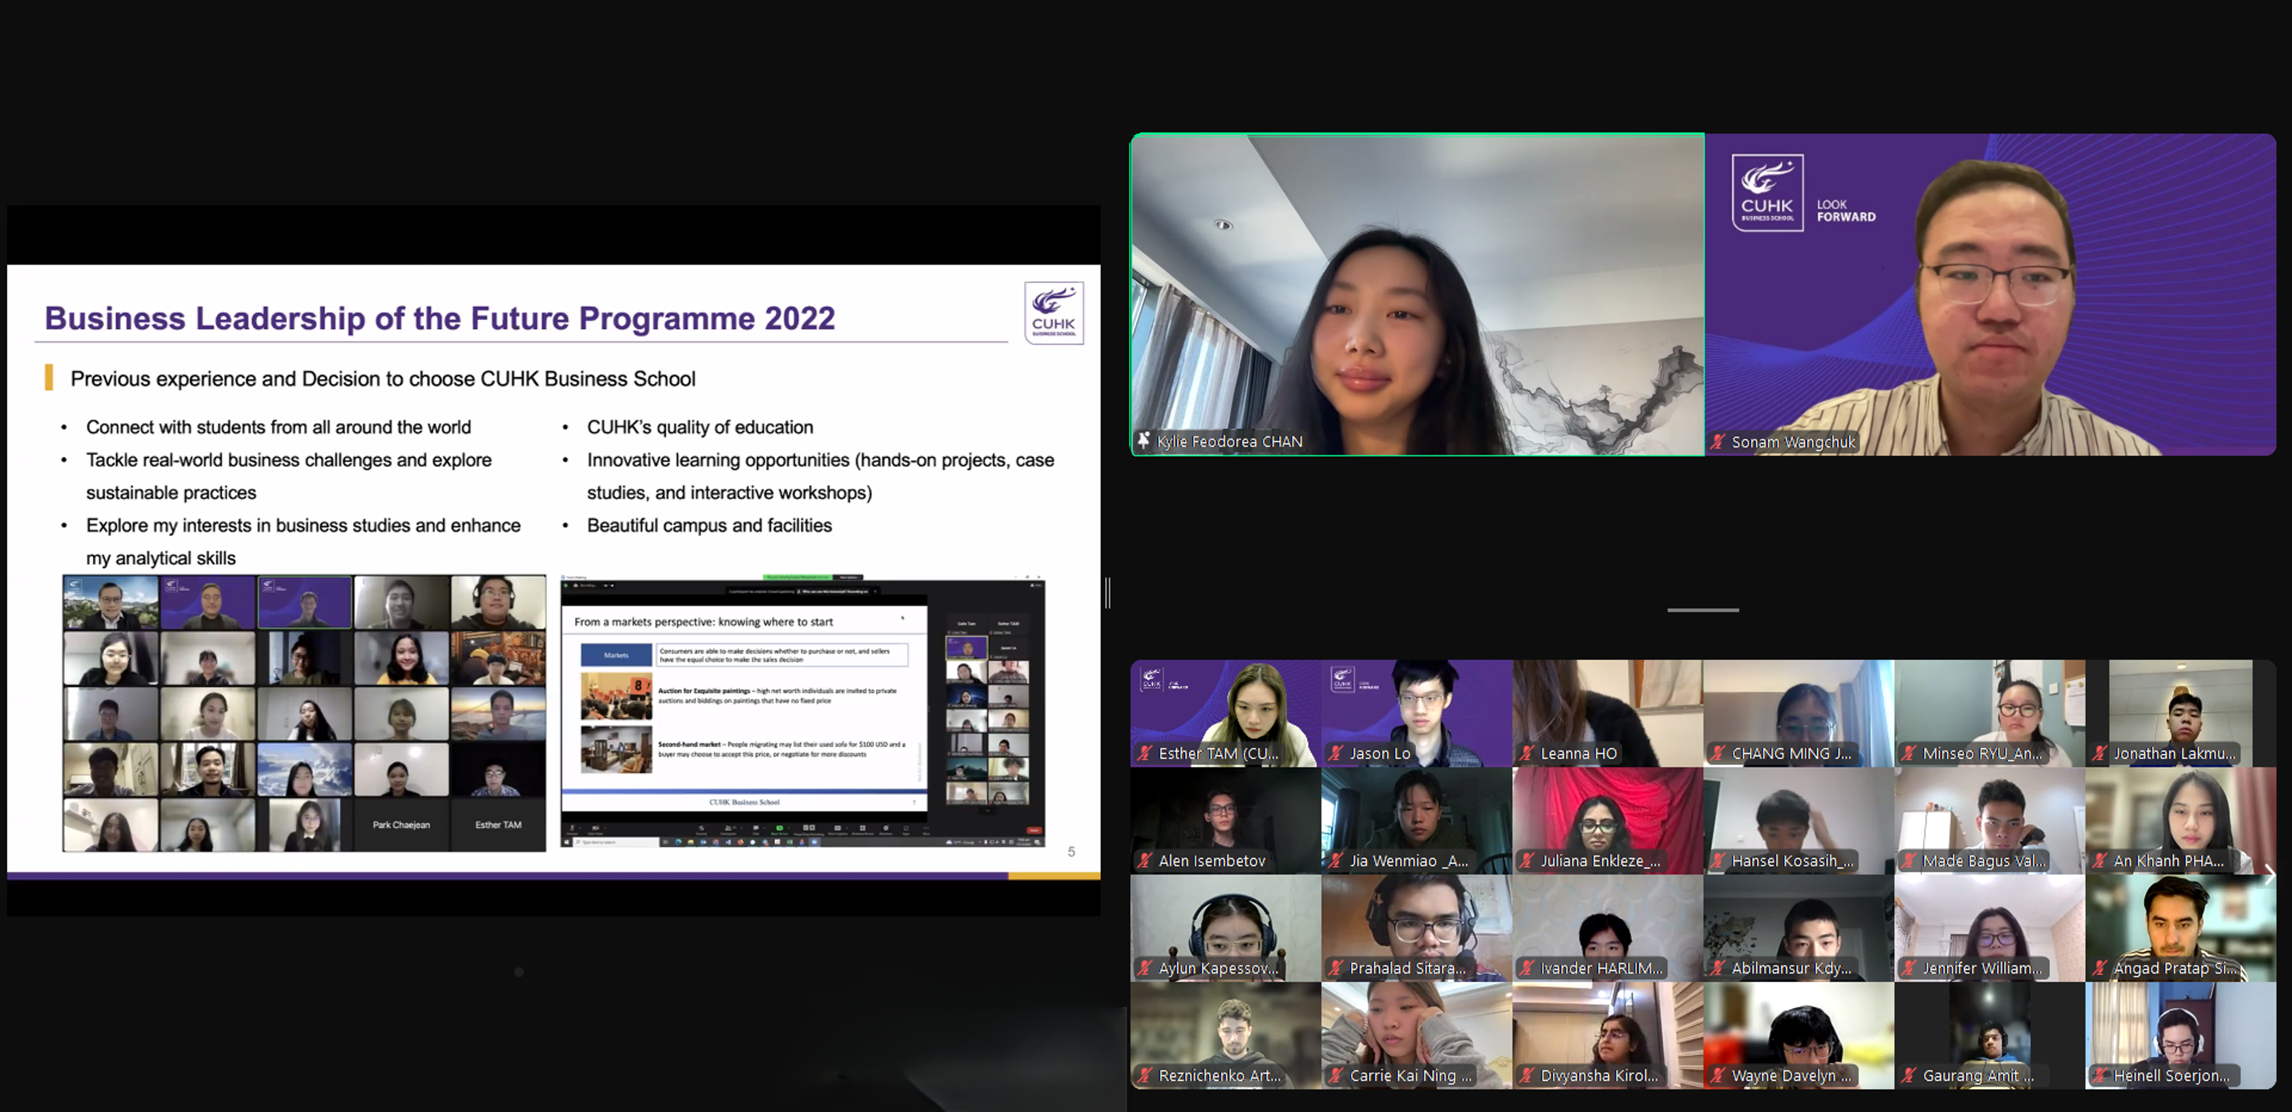Kylie CHAN (IBBA, Year 2) shared her previous experience of this programme when she participated in 2022
Both students’ sharing showcased CUHK’s diverse community, highlighting the various backgrounds that enrich the university life and enhance the educational environment for all participants. At the end, they shared some essential guidance for participants on studying overseas and preparing for their new chapter in university.
A Business Case Studies Competition
A highlight of the programme was the mini business case studies competition, which brought together students from various countries to showcase their diverse learning backgrounds and perspectives. Participants collaborated in multicultural teams to tackle a case study about a plant-based meat brand. In this vibrant setting, they engaged in rich discussions and shared unique perspectives to solve real-world business problems. This collaborative fostered not only teamwork but also a profound exchange of ideas and knowledge.
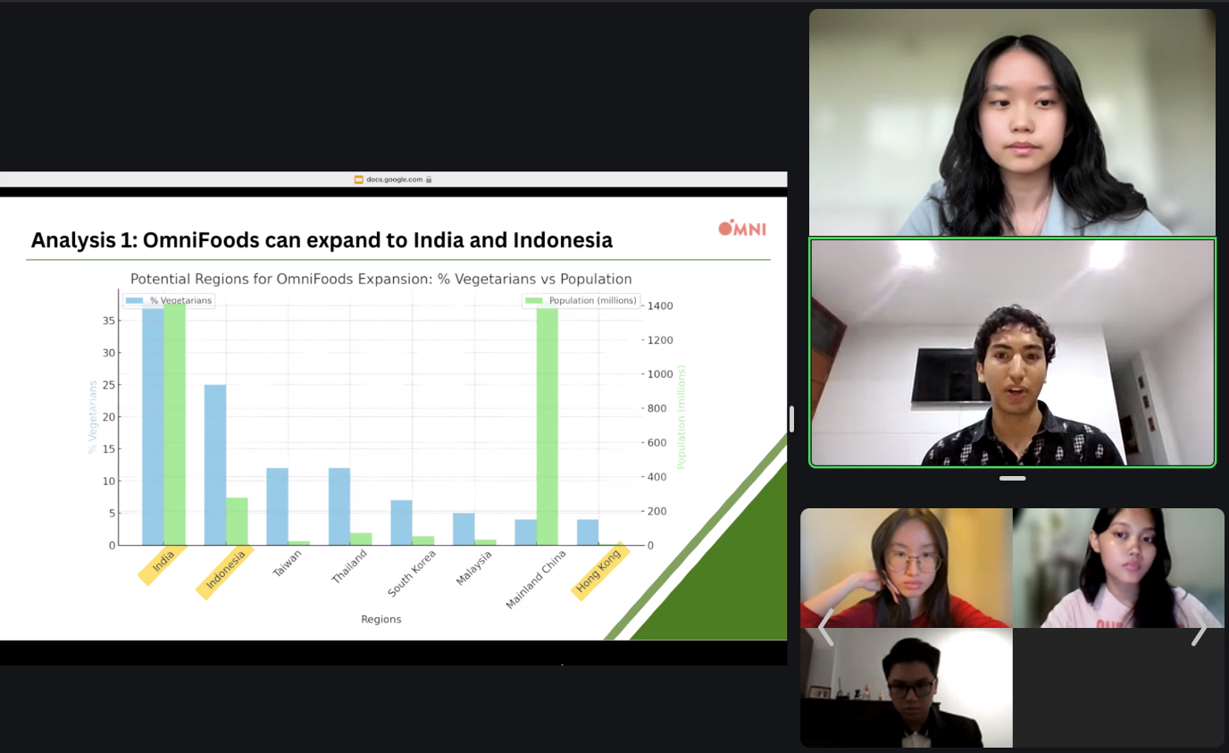Participants shared their presentation of the case study
Conclusion
This programme exemplifies CUHK’s commitment to nurturing global talent and fostering a diverse learning environment. By connecting high school students with experienced educators and current university students, we are paving the way for the next generation of business leaders to thrive in an interconnected world.
A heartfelt thank you to our esteemed judges and speakers for their invaluable contributions during the weekend! We also want to express our gratitude to those high school students who transcended time zones and geographical boundaries to join us.
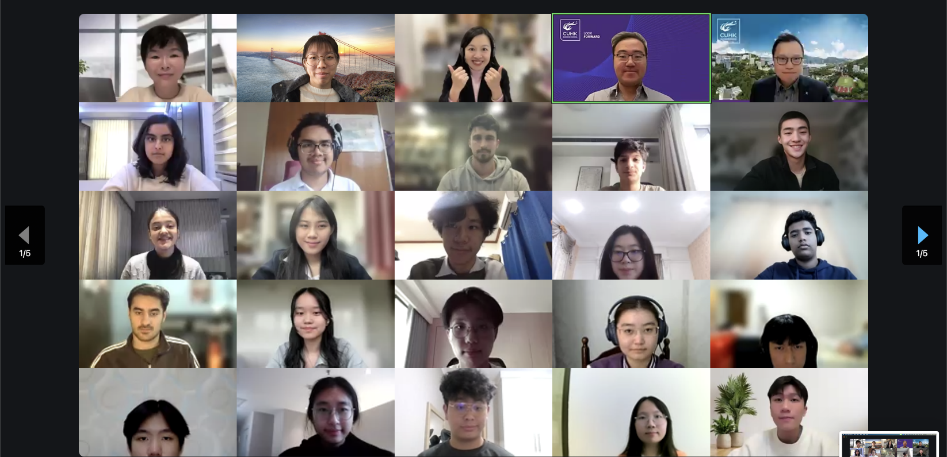
#Photos will be modified with marcom team#

